QUESTION # 1: ZERO-SHOT PROMPTING
Write a simple instruction asking the AI to summarize a story or decide if a review is positive or negative. Do not give the AI any example
PROMPT:
REVIEW: “The food was very spicy and the quantity was also less”
On the bases of given review decide whether the review is positive or negative. Give your answer only in positive or negative
OUTPUT:
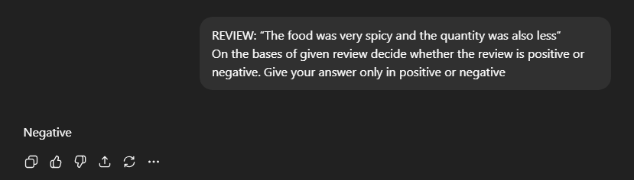
QUESTION # 2: ONE-SHOT PROMPTING
Create a prompt that shows the AI how to do a task by giving it only one example. For instance, show it how to change “John Doe” to “Doe, John”, and ask it to do the same for a new name.
PROMPT:
Reverse the given name in a format of (Last Name, First Name). For example, convert
John Doe into Doe, John.
Name: Amna Vaqar
OUTPUT:

QUESTION # 3: FEW SHOT PROMPTING
Write a prompt that give the AI three example of a specific writing style (Like a poem or a short product description). Then, ask the AI to write a new one using the same style.
PROMPT:
Write a product description in a format like;
Example 1:
Name: Weight Machine
Description: Keep the track of your weight and helps you to stay fit and healthy
Example 2:
Name: Smart Watch
Description: A device perfect combination of comfort and luxury ,designed to make daily task easy as well as keep the track of your health
Example 3:
Name: Laptop Backpack
Description: Elegant design with multiple compartments as well as inbuilt cables designed specifically to keep your laptop device safe
Now write the description for:
Name: Ear pods
OUTPUT:
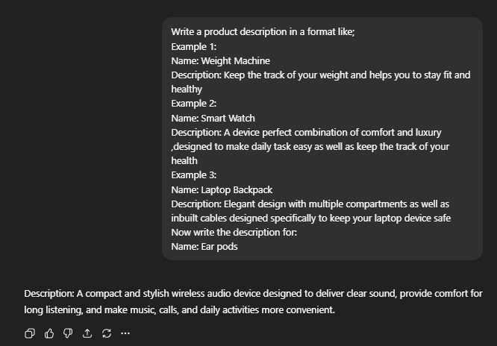
QUESTION # 4: SYSTEM PROMPTING
Write a set of main rules for an AI, tell it how it must always behave, what thing it is not allowed to say, and what kind of tone it should use when talking to customer
PROMPT:
You are a professional assistant for an online electronics store.
Rules:
1. Always be polite and professional with your customer.
2. Provide clear and helpful answers to the customer
3. Do not give false information.
4. If you do not know the answer, say you will check with the support team.
Question:
My ear pod stopped working after two weeks. What should I do?
OUTPUT:
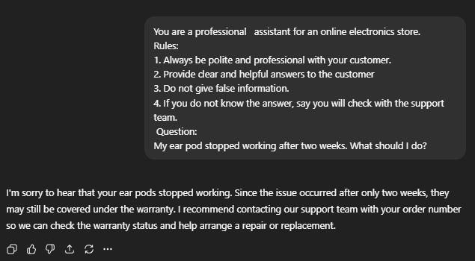
QUESTION # 5: ROLE PROMPTING
write a prompt that tells the AI to act like a professional expert, such as a doctor, a lawyer or, a history teacher. Ask it a question that only someone in that job would know how to answer well.
PROMPT:
Act as a professional doctor. A patient ask that, he have a mild fever and head ache, how to treat it .
OUTPUT:
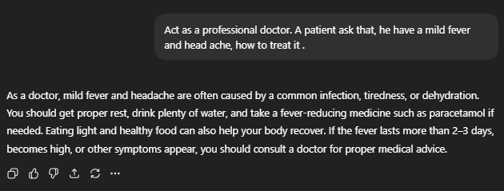
QUESTION # 6: CONTEXTUAL PROMPTING
Write a prompt that gives the AI a lot of extra information first, such as fact about the business or a specific problem. Then ask the AI to create a plan based only on the information provided.
PROMPT:
A school has the following situation:
- The school has 500 students.
- Many students submit assignments late.
- Teachers complain about poor time management.
- The school uses an online learning system but students rarely check it.
Based only on this information, create a simple plan to improve assignment submission and student responsibility.
OUTPUT:
